Generate RSA key by Openssl
Command Line
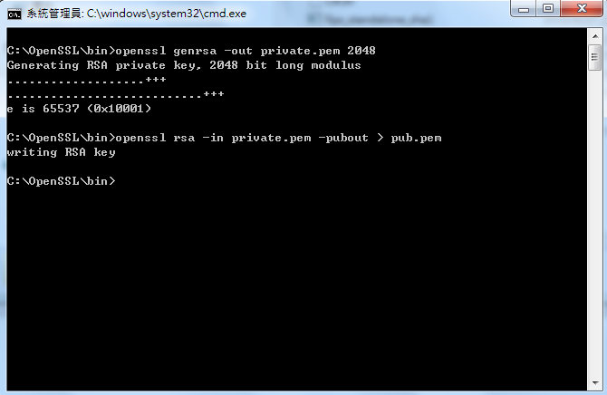

Input : openssl genrsa –out private.pem 2048
Output: private.pem ( RSA private key)

Input : openssl rsa –in private.pem –pubout > pub.pem
Output : pub.pem ( RSA public key)


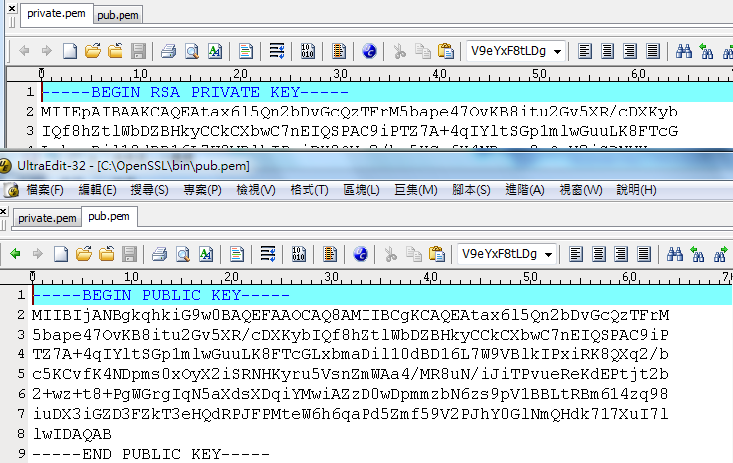
Input : openssl rsa –pubin –in pub.pem –text –out pub1.txt
Output : pub1.txt ( RSA public key)
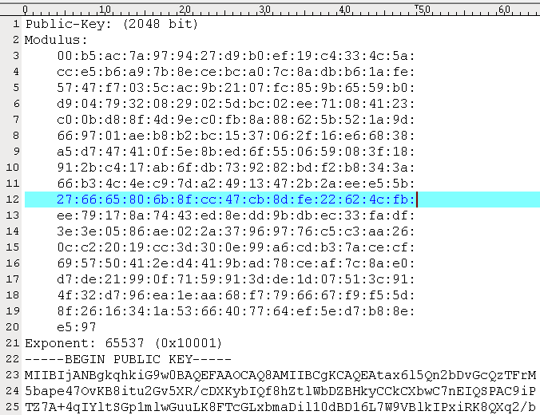

It’s other option to get above data from website.
Ex : https://lapo.it/asn1js/
